Rathael (in short of Aelirathaelonar)— The Moon Between Blades
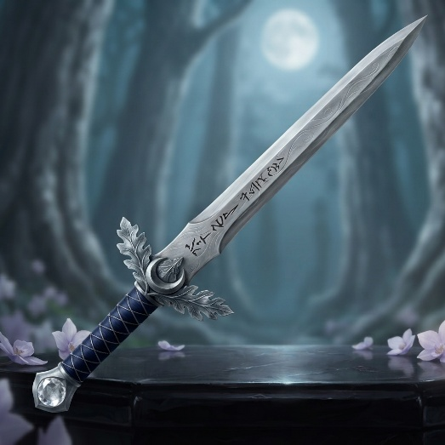
Aναγνωρίζει μόνο αίμα του Οίκου Dahast.
Weapon: Long sword
Alignment: Chaotic Good
Intelligence: 14
Ego: 18
Vaelthir +3, +4 under full Moon (+1 under moonless night).
Bladesong ability: Moonstep: Once per encounter, while the character is actively using his Bladesong, he may make a special movement. Instead of making a normal attack, he may move up to 10 feet without provoking a free attack from an opponent he is currently engaged with.
At the end of the movement he may immediately make one attack at +2 to hit.
This isn't teleportation. The character simply moves with such extraordinary grace that opponents lose track of his position.
At levels above 10, this increases to twice per combat.
Moonstep cannot be used under moonless nights.
Moon's Reflection: 1/day, when the character is targeted by a spell requiring an attack roll, he may cause the sword to flash with pale light. The attacker suffers –2 to the spell attack roll.
Against magic missile, one missile automatically misses.
Other Powers: Light (1/day). Song of the Shield (1/day), within the bladesong, all allies within 30’ receive a +1 AC and +1 on save vs.spell for 1 rd/lvl. Minor Globe of Invulnerability (1/day).
History: Rathael was originally created by a Dahast bladesinger during the earliest generations of the family's presence in Cormanthyr, namely Lord Ilhaerith and was given to his sister Ilharessa Dahast.
Forged from pristine mithral in the tree-dwellings of Villa Dahast, this elegant weapon features a crossguard sculpted to resemble stylized elven oak leaves enclosing a crescent moon. The blade remains utterly silent until the wielder begins the Bladesong, at which point it emits a low, resonant chime that matches the tempo of the bladesinger’s movements
The sword became known as The Moon Between Blades.
Unlike other similar swords, it was not passed automatically from parent to child. It was passed to the next person judged worthy to carry the Dahast blade.
On the blade, 6 runes were engraved, forming 6 stanzas, one for each rune (Ae-li-ra-thae-lo-nar).
The last one, the Rune of the White Tree, etched near the forte of the blade, concealed beneath layers of old elven polishing, is an ancient, stylized elven glyph that you recently managed to decipher. However, translating the words has only revealed a mystical puzzle. Once deciphered, the rune flashed silver and revealed a telepathic vision: “The steel is but a cold cage for the song. To wake the apex of Dahast, the blade must drink the unfallen tear of Sehanine's Daughter, wept at the exact moment the autumn wind breathes upon the silver-leaf root.”

